CMS Provider Enrollment [TEST] Deployment Guide

Revision History
Author | Revision Number | Date

Deployment Instructions 3
1. Organization of Submission 3
2. Application Setup 3
3. build.properties File 4
4. Build Scripts Setup 4
5. Database Setup 4
6. Deployment Instructions 4
7. Starting 5
8. Verification 5
9. Resource Contact List 6
JBoss CXF Setup 6
Drools Guvnor Setup 6
Import Guvnor Repository 6

Deployment Instructions

Organization of Submission

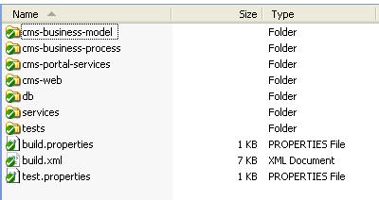

cms-business-model - contains web service and domain schema definitions and JAXB generated java models from the schema, this model is used by the web services, business rules and the web application

cms-business-process - contains business process and workflow related sources

cms-portal-services - contains enterprise archive metadata and shared libraries across all modules

cms-web - contains the front-end application code

services - contains EJBs for persistence and common application services used by the front end and the business process. It also contains the application configuration

services/src/main/resources/cms.properties

db - contains the database related files

tests - contains test files and unit tests

Application Setup

The application requires the following systems:

- JDK6+
- Oracle 11g Database
- JBoss Application Server 5.1 GA
- JBPM 5.3.0
- Drools
- JBoss Drools 5.3
- LDAP or any directory based identity management. Requires knowledge of the existing user/group schema
- CMS External Sources Application

See Appendix for Drools guvnor setup

build.properties File

Property Name | File property is stored | Example Setting
jboss.home | build.properties | /usr/local/jboss/jboss-5.1.0.GA
jBPM.home | build.properties | /usr/local/jboss/jbpm-5.3.0.Final-bin
jdbc.url | build.properties | jdbc:oracle:thin:@ORACLESERVER:1521:orcl
jdbc.user | build.properties | cms
jdbc.pass | build.properties

Build Scripts Setup

build-core Builds the core archive
build-ejb Builds the EJB archive
build-war Builds the web archive
clean Removes all generated files
deploy Deploys the portal ear artifact
deploy-ds Deploys the datasource definition to the application server
regenerate-model Regenerates the application model from the schemas

Database Setup

db/mita3.sql - contains the database table definitions for the JBPM task services and the provider enrollment portal

cms-web/src/main/resources/web-test-data.sql - contains data for development and testing the provider enrollment portal

Deployment Instructions

- Create the database by executing the sql files listed in section 5.
- Update services/src/main/resources/cms.properties to reflect the user-group structure of the third party directory provider chosen (schema may vary), password encryption is optional for local deployment, otherwise, please use JASYPT to encrypt any property you wish to protect

#LDAP settings
ldap.java.naming.factory.initial=com.sun.jndi.ldap.LdapCtxFactory
ldap.java.naming.provider.url=<LDAP SERVER URL>
ldap.java.naming.security.authentication=simple
ldap.java.naming.security.principal=<LDAP ADMIN>
ldap.java.naming.security.credentials=<LDAP ADMIN PASSWORD>

# replace with Directory Provider Schema properties (slightly varies per product)
ldap.userDnPattern=<DISTINGUISHED NAME PATTERN FOR USERS>
ldap.groupsSearchBase=<SEARCH BASE FOR GROUPS>
ldap.userSearchBase=<SEARCH BASE FOR USERS>
ldap.userSearchFilter=<SEARCH PATTERN FOR USERS>
ldap.groupSearchFilter=<SEARCH PATTERN FOR GROUP MEMBERS>

extsources.TEST.base=<ENDPOINT BASE URL FOR EXT SOURCES APP>

- Make sure you update build.properties to reflect the jboss location
- Import db/guvnor/repository-export to the BRMS (see appendix)
- Deploy the JBOSS datasources by executing ant deploy-ds
- Deploy the application by executing ant deploy

You need to add the following groups to your Directory Provider

  - Provider
  - Service Agent
  - Service Administrator
  - System Administrator

Create at least one administrator on LDAP then insert the same username into CMS_USER to enable this user in CMS (a sample insert is included in web-test-data.sql). All other users can sign up or be created by this administrator.

Starting

Start jboss using the stadard scripts in <jboss>/bin

Verification

- Open http://localhost:8080/cms/login and login as the administrator or sign up for a new account.
- If your deployment is successful, you should be directed to the dashboard for the role you have logged in as.

Resource Contact List

Name | Resource Email

Appendix A

JBoss CXF Setup

https://community.jboss.org/wiki/JBossWS-Installation

- Download and extract v3.4.0 from http://www.jboss.org/jbossws/downloads
- Copy ant.properties.examples to ant.properties
- Modify ant.properties file accordingly. The most important properties are jboss510.home and jbossws.integration.target.
- Execute deploy for jboss 5.1.0

ant -Djboss.server.instance=default deploy-jboss510

Drools Guvnor Setup

Download the software from http://download.jboss.org/drools/release/5.2.0.Final/

- EXTRACT guvnor-5.2.0.Final-jboss-as-5.1.war(from the binaries folder of the distribution) to <jboss.as.home>/server/default-with-hornetq/deploy/guvnor-webapp.war
- Remove the following libraries from the WEB-INF/lib (they are provided by the ESB cxf stack and will cause conflicts – only the jaxrs cxf dependency will remain)

- cxf-api-2.3.1.jar
- cxf-common-utilities-2.3.1.jar
- cxf-rt-core-2.3.1.jar
- cxf-rt-transports-http-2.3.1.jar
- cxf-common-schemas-2.3.1.jar
- cxf-rt-bindings-xml-2.3.1.jar

- Start jboss and open the guvnor console http://localhost:8080/guvnor-webapp
- This will prompt to install sample repositories, click Yes.

Import Guvnor Repository

To simplify testing, please import the provided export file from the guvnor administration console.

- Open Guvnor and Import the repository_export/repository_export.xml

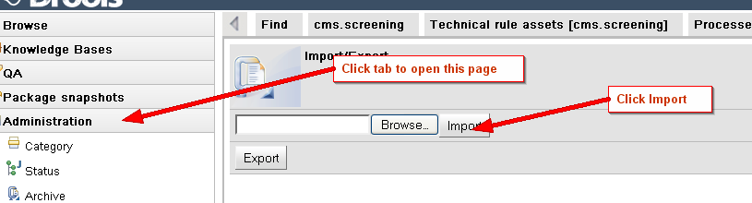
- To merge to an existing repository (for integration), please use the Jboss IDE to check in the files in cms-business-rules/src/rules to your target server.

